**MINISTRY OF EDUCATION AND TRAINING**

**DUY TAN UNIVERSITY**



**RENTING HELPER -**

**A SUPPORT SYSTEM FOR**

**FINDING HOUSE FOR RENT ON ANDROID OS**

# 🙠🖎🕮✍🙢

**USER STORIES DOCUMENT**

**TEAM MEMBERS**

1. **NGUYEN LUONG HOANG - 1560**
2. **NGUYEN NGOC VU - 1579**
3. **HUA THI THONG - 6419**
4. **NGUYEN DINH THI NGOC DIEP - 1558**
5. **TRAN VAN THANH - 1571**

**Da Nang, Feb-2018**

|  |  |  |  |  |
| --- | --- | --- | --- | --- |
| **PROJECT INFORMATION** | | | | |
| **Project Acronym** | RH | | | |
| **Project Title** | Renting helper - a support system for finding house for rent on Android OS | | | |
| **Start Date** | 01– Feb – 2018 | **End Date** | 15 – Mar – 2018 | |
| **Lead Institution** | Department Of Information Technology, Duy Tan University | | | |
| **Project Mentor** | Thi S. T. TRINH  Email: trinhsutruongthi@gmail.com  Phone: 0905.723.278 | | | |
| **Product Owner & Contact Detail** | Diep D. T. N. NGUYEN  Email: diep.nguyendtngoc@gmail.com  Phone: 0905.517.760 | | | |
| **Partner Organization** | Duy Tan University | | | |
| **Project Manager &Scrum Master** | Hoang L. NGUYEN | luonghoangdn92@gmail.com | | 0934.799.890 |
| **Team Members** | Vu N. NGUYEN | nnvu92@gmail.com | | 0906.351.761 |
| Thong T. HUA | huathithong93@gmail.com | | 01683.698.807 |
| Thanh V. TRAN | tranvanthanh217@gmail.com | | 01647.187.783 |
| Diep D. T. N. NGUYEN | diep.nguyendtngoc@gmail.com | | 0905.517.760 |

|  |  |  |  |
| --- | --- | --- | --- |
| **DOCUMENT NAME** | | | |
| Document Title | User Stories Document | | |
| Author(s) | Diep D. T. N. NGUYEN | | |
| Role | Team member | | |
| Date | 15 – Feb – 2018 | File name: | [RH]UserStories-ver.1.0.docx |
| URL |  | | |
| Access |  | | |

|  |  |  |  |
| --- | --- | --- | --- |
| **REVISION HISTORY** | | | |
| Version | Person | Date | Description |
| 1.0 | Diep D. T. N. NGUYEN | 15 – Feb – 2018 | Create document |

|  |  |  |  |
| --- | --- | --- | --- |
| **Document Approval**  The following signatures are required for approval of this document | | | |
| **Mentor** | Thi S. T. TRINH | **Signature:** |  |
| **Date:** |  |
| **Product Owner** | Diep D. T. N. NGUYEN | **Signature:** |  |
| **Date:** |  |
| **Scrum Master** | Hoang L. NGUYEN | **Signature:** |  |
| **Date:** |  |
| **Team Member(s)** | Diep D. T. N. NGUYEN | **Signature:** |  |
| **Date:** |  |
| Vu N. NGUYEN | **Signature:** |  |
| **Date:** |  |
| Thanh V. TRAN | **Signature:** |  |
| **Date:** |  |
| Thong T. HUA | **Signature:** |  |
| **Date:** |  |

TABLE OF CONTENTS

1. INTRODUCTION 1

1.1. Document overview 1

1.2. Business values 1

2. USER STORIES OF RENTING HELPER 2

2.1. US01-Show list of houses for rent on map 2

2.2. US02-Show filtered list 2

2.3. US03-Show list of houses 2

2.4. US04-Show detail information of house 3

2.5. US05-Call house owner 3

2.6. US06-Rate marks 3

2.7. US07-Post house for rent 3

3. USE CASE 4

3.1. Use case 1: Overview 4

3.2. Use case 2: Find renting house 6

3.3. Use case 3: Post house for rent 7

4. TABLE USER STORIES’S PRIORITY: 9

LIST OF TABLES

Table 3.1: Use Case Overview 5

Table 3.2: Use Case Find Renting House 6

Table 3.3: Use Case Post house for rent 7

Table 4.1: User Story’s Priority. 9

LIST OF FIGURES

Figure 3.1: Use Case Overview 4

Figure 3.2: Use Case Find Renting House 6

Figure 3.3: Use Case Post House For Rent 7

# INTRODUCTION

In the field of software development, User Story (User Stories) is one or more sentences describing natural language (not technical language) or business language of the end user or system user to record what the user needs to do or not to do as part of their job or task. User stories are used in methods like Agile software development is the basis for determining the functions of the system are business development and create favorable conditions for requirements management. Help yourself to know the “who”, “what” and “why” in a simple request, short, often only limited by what details can be written on a piece of paper notes, small scrap paper.

With user story, this allows development team to spend time with the user and better understand the functionality that they want.. In this application, the main functionality is to help user to find a renting house easily. The use of user stories also understands most of the process, work flow and functionality of the system should be working now.

User story can also be written by developer to express non-functional requirements (such as security, performance, quality).

## Document overview

This document provides a user story and goal-oriented view of the Renting Helper System project which delivers several key project benefits below:

* It helps answer the question “What does this project do?” for the business, project sponsors, developers and architects including clearly defining scope.
* It supports to define target and future state architectures.
* It helps understand required capabilities to support a project.
* It provides a meaningful resource which can be used in conversation between the business and architecture team.

## Business values

Our team recommends building the “Renting Helper System” application with some special features for users:

* Finding renting house/room
* Posting house/room for rent
* Viewing place on google map
* Contact house owner by supplied phone number
* Rating marks for renting place

With that features, we hope the system will bring more advantages for public. It helps people to feel more comfortable, more convenient when finding a house for rent. People can find new houses in an effective and effortless way without taking too much time to go seeking houses outside.

# USER STORIES OF RENTING HELPER

## US01-Show list of houses for rent on map

|  |
| --- |
| **As a User**   * First of all, after accessing the application successfully. * After login successfully, I choose a city where I want to rent house. * Click OK and I see houses are shown on map. |

## US02-Show filtered list

|  |
| --- |
| **As a User**   * First of all, after accessing the application successfully. * After login successfully, I choose a city where I want to rent house. * Click OK and I see a list of houses are shown on map. * Click Filter button and choose a condition I want to filter such ass money, distance, … * Click apply button, I see a list of filtered houses on map. |

## US03-Show list of houses

|  |
| --- |
| **As a User**   * First of all, after accessing the application successfully. * After login successfully, I choose a city where I want to rent house. * Click OK and I see a list of houses are shown on map. * Click the list mode button, I can see houses are displayed in list mode. |

## US04-Show detail information of house

|  |
| --- |
| **As a User**   * First of all, after accessing the application successfully. * After login successfully, I choose a city where I want to rent house. * Click OK and I see a list of houses are shown on map. * Click a house to view its detailed information such as address, money, images, … |

## US05-Call house owner

|  |
| --- |
| **As a User**   * First of all, after accessing the application successfully. * After login successfully, I choose a city where I want to rent house. * Click OK and I see a list of houses are shown on map. * Click a house to view its detailed information * Click on house owner’s phone number to make a phone call |

## US06-Rate marks

|  |
| --- |
| **As a User**   * First of all, after accessing the application successfully. * After login successfully, I choose a city where I want to rent house. * Click OK and I see a list of houses are shown on map. * Click a house to view its detailed information * Choose rate scores and comment |

## US07-Post house for rent

|  |
| --- |
| **As a User**   * First of all, after accessing the application successfully. * After login successfully, I click post house button * Input house’s information and contact information * Upload images * Click OK button |

# USE CASE

## Use case 1: Overview

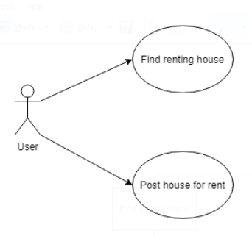

###### Figure 3.1: Use Case Overview

##### Table 3.1: Use Case Overview

|  |  |
| --- | --- |
| Use Case ID | UC 1 |
| Use Case Name | Overview |
| Create By | Diep D. T. N. NGUYEN |
| Date Create | 15 – Feb – 2018 |
| Actors | User |
| Description | This use case describes how User uses the system to find house or post house for rent. |
| Trigger | The user indicates that they want to use the functions that they have selected. |
| Pre – Conditions | User logins the system successfully, and also need to choose what function they want. |
| Post – Conditions | The user will use the function that they have selected . |
| Normal Flow | Select the lookup: The system will show a list of house for rent available for user to choose.  User can click post house button if user wants to rent user’s house. |
| Alternative Flow | The system will return information that user have selected. |
| Exceptions |  |
| Include |  |
| Special Requirement | Software play on Android OS.  That function is existed. |

## Use case 2: Find renting house

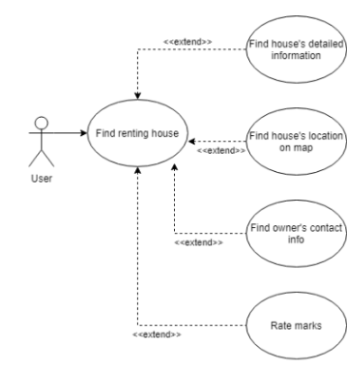

###### Figure 3.2: Use Case Find Renting House

##### Table 3.2: Use Case Find Renting House

|  |  |
| --- | --- |
| Use Case Name | Find Renting House List |
| Create By | Diep D. T. N. NGUYEN |
| Date Create | 15 – Feb – 2018 |
| Actors | User |
| Description | This use case describes how user can find renting house. Other hand, they also can see house’s detailed information, location on map, owner contact, rate marks. |
| Trigger | The user indicates that they want to use the functions that they have selected. |
| Pre – Conditions | User logins the system successfully |
| Post – Conditions | The user will use the function that they have selected. |
| Normal Flow | User chooses a location  Click on a house to view detail information  Click on address to view location on map  Click on owner’s phone number to make a phone call  Rate marks |
| Alternative Flow | The system will display house’s information |
| Exceptions |  |
| Include |  |
| Special Requirement | Software play on Android OS.  That function is existed. |

## Use case 3: Post house for rent

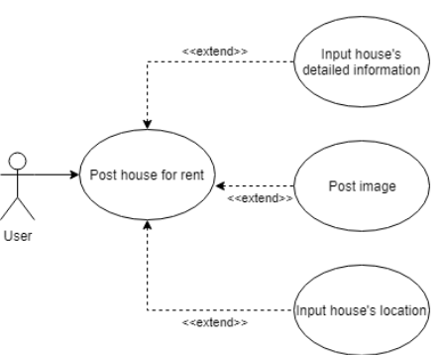

###### Figure 3.3: Use Case Post House For Rent

##### Table 3.3: Use Case Post house for rent

|  |  |
| --- | --- |
| Use Case ID | UC 3 |
| Use Case Name | Post house for rent |
| Create By | Diep D. T. N. NGUYEN |
| Date Create | 15 – Feb – 2018 |
| Actors | User |
| Description | This use case describes how user post their house information to the system so that other people can rent it. |
| Trigger | The user indicates that they want to use the functions that they have selected. |
| Pre – Conditions | User logins the system successfully |
| Post – Conditions | The user will use the function that they have selected. |
| Normal Flow | User click post house button  Input house’s information  Post images  Input house’s location |
| Alternative Flow | The system will display guide to show the suggest way step by step. |
| Exceptions |  |
| Include |  |
| Special Requirement | Software play on Android OS.  That function is existed. |

# TABLE USER STORIES’S PRIORITY:

##### Table 4.1: User Story’s Priority.

|  |  |  |  |
| --- | --- | --- | --- |
| User Story ID | User Story Name | Priority | Estimate hour(s) |
| US01 | Show list of houses for rent on map | must have | 10 |
| US02 | Show filtered list | must have | 8 |
| US03 | Show list of houses | must have | 10 |
| US04 | Show detail information of house | must have | 8 |
| US05 | Call house owner | must have | 8 |
| US06 | Rate marks | optional | 10 |
| US07 | Post house for rent | must have | 20 |